Aide contextuelle du logiciel Tachograph

(Issue de l'aide interactive du logiciel)

A. Introduction 2

B. File 2

1) Open 2

2) Save 2

3) Close 3

4) Print 3

5) Exit 3

C. Import_Export : 3

6) Communication 3

7) Download the data 3

8) Memory Reset 3

9) EXCEL 3

D. Edit : 4

10) Alarm 4

11) Min - Max 5

12) Text insert 5

13) Copy window 6

14) Rename window 6

E. Treatment of the data : 6

15) Moving average 6

16) Position 6

17) Acceleration 6

F. Options : 6

18) Language 6

19) Save settings on exit 7

G. Display : 7

20) Graticule 7

21) Variation cursors 7

22) Legend 7

23) Colors 7

24) Scales 7

25) Zoom 8

H. Window : 8

26) Cascade 8

27) Tile 8

28) Full screen 8

I. ? : 8

29) Summary 8

30) Help on help 9

31) About TACHOGRAPH 9

# Introduction

The TACHOGRAPH software is an application that runs on a PC with Windows NT , Windows 2000 , Windows XP or Windows Vista.

It has the following functionalities:

- retrieval and display of the measurements recorded by the instrument,

- the counting of the integral and the stemming of a curve (position and acceleration),

- the filtration of a recording by moving average,

- the exporting of the different curves acquired into EXCEL.

# File

## Open

This option allows you to open a data file:

* .MON for a recording from the instrument
* .TCM for a recording of the displayed graph

This option is available in the toolbar when clicking on the icon : 

## Save

This option can save the results in a data file (.tcm).

The data file created can be loaded with the option Open.

This option is available in the toolbar when clicking on the icon : 

## Close

This option closes the active graph.

This option is available in the toolbar when clicking on the icon : 

## Print

This option enables measurements to be printed (graph).

This option is available in the toolbar when clicking on the icon : 

## Exit

This option can quit the TACHOGRAPH application.

If acquisition is in progress, it will be stopped.

# Import_Export :

## Communication

This option allows you to choose the PC serial port to communicate with the instrument.

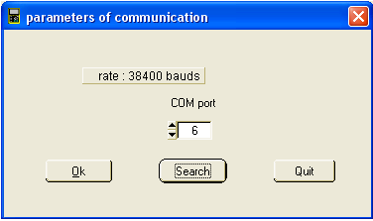

## Download the data

This option can be used to import the files stored in the instrument (recordings).

This option is available in the toolbar when clicking on the icon : 

## Memory Reset

This option erases all the measurements stored in the instrument.

## EXCEL

This option can export measurement results to EXCEL.

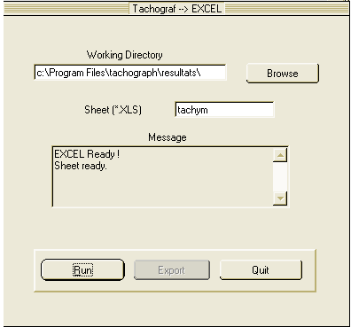

EXCEL starts by clicking on the Run EXCEL button.

If the launching is successful, a second message “EXCEL Ready!” is displayed. So, the datas can be exported by clicking on the Export button.

The dialog box can be used to select the name and the destination of the calculation sheet, where the data will be exported.

The Message control informs about the nature and the result of the different procedures.

This option is available in the toolbar when clicking on the icon : .

# Edit :

## Alarm

This option enables the visual alarms on the graph to be defined.

These alarms will appear in black.

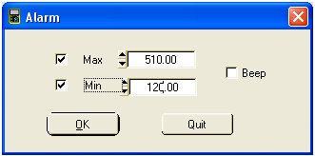

## Min - Max

This option searches automatically the minimum or maximum point on the graph.

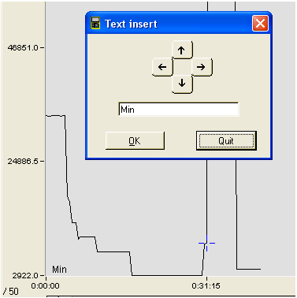

Moreover, it allows to add text corresponding to this point and to move it along the graph.

## Text insert

This option allows to insert text and to move it along the graph.

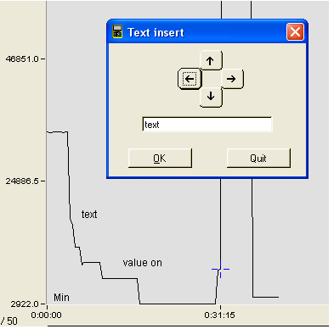

The user may insert 3 different texts.

## Copy window

This option can copy the screen.

Everything than can be seen on the screen will be copied in the clipboard to be worked out in any other Windows application.

## Rename window

This command modifies the title of the selected window.

# Treatment of the data :

## Moving average

This option performs smoothing (moving average calculation) on the selected recording.

The filtering principle involves calculating a moving average of the last N points in the recording. This average value is the filter output value.

The filtering is calculated as follows:

$$Filtered measurement =\frac{Sum of the last K measurements}{K}$$

where K is the constant expressed as a number of measurements.

## Position

This option calculates the integral (or position/displacement) of the points in the recording selected.

The position values are calculated as follows:

$$\frac{\left(Sum of the final speed and initial speed\right)* \left(time interval between these two speeds\right)}{2}$$

## Acceleration

This option calculates the differential coefficient (or acceleration) of the points in the recording selected.

The acceleration values are calculated as follows:

$$\frac{\left(Difference between the final speed and the initial speed\right)}{\left(time interval between these 2 positions\right)}$$

# Options :

## Language

This option can select the application language : french, english , german , spanish , italian.

## Save settings on exit

This option can save the general setting on quitting the application.

It can thus open the application as it was on exit.

# Display :

## Graticule

Enable or disable displaying the graticule on the graph.

This option is available in the toolbar when clicking on the icon : 

## Variation cursors

Enable or disable displaying cursors on the graph.

Click on the cross of intersection of cursors to move them.

This option is available in the toolbar when clicking on the icon : 

## Legend

Enable or disable displaying signal acquisition characteristics for the graph.

The caption indicates the x- and y-axis of the blue cursor.

If the variation cursors are displayed, their values appear in the caption too.

This option is available in the toolbar when clicking on the icon : 

## Colors

This option modifies the different colors of TACHOGRAPH window.

Click on the bar of color to change it.

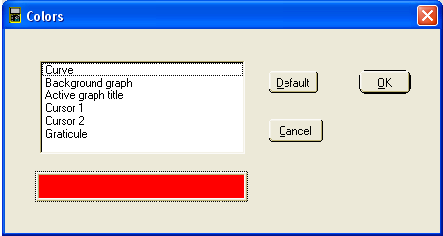

## Scales

This option enables the scale of the graph to be chosen: manual or automatic.

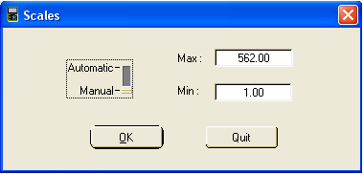

## Zoom

This option can expand or compress a curve.

The zoom value is displayed at the bottom of the graph.

By default, the zoom is neutral and its value is x 1.

Each click on Zoom in button increase or decrease the zoom value from x 10 to / 200.

This option is available in the toolbar when clicking on the icons :  and

# Window :

## Cascade

This function replaces all graphs in the TACHOGRAPH window so that they are partially visible.

This option is available in the toolbar when clicking on the icon : 

## Tile

This function replaces all graphs in the TACHOGRAPH window so that they are fully visible.

This option is available in the toolbar when clicking on the icon : 

## Full screen

This option can be used to display the selected window in full-screen mode. Pressing it a second time returns the window to its original size.

This option is available in the toolbar when clicking on the icon: 

# ? :

## Summary

This option runs the help file TACHOGRAPH.HLP

This option is available in the toolbar when clicking on the icon : 

Shortcut Key : F1

## Help on help

This option displayed all key words in alphabetic order included in the help file TACHOGRAPH.HLP

In this way, the required help can be accessed directly.

## About TACHOGRAPH

This option can displaying the informations of TACHOGRAPH.